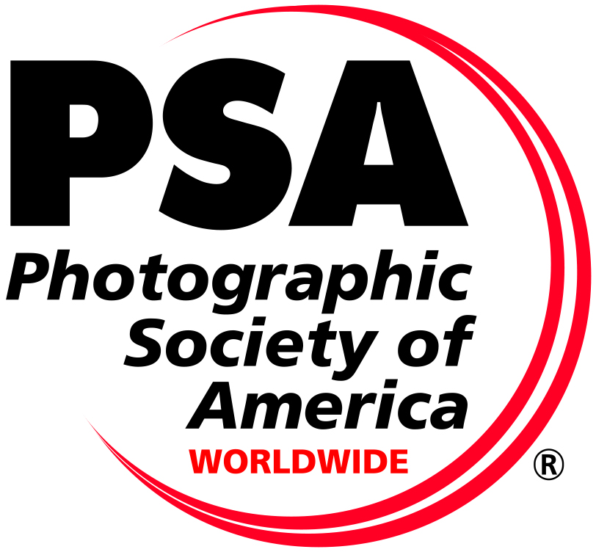

PERMISSION FOR PSA TO USE IMAGES

I hereby give permission for the Photographic Society of America (PSA) to display any of my images submitted through my Wasatch Camera Club for use in PSA inter-club competitions. I certify that I am the copyright holder of the images. I hereby agree that this work is my original work created solely by me and does not infringe on the copyrights, trademarks, oral rights, rights of privacy/publicity or intellectual property rights of any person or party.
I hereby give permission for the Photographic Society of America to display such images on the PSA's own website and Vimeo. (Vimeo is used to display Best of Year movie presentations.)
I retain copyright of the image(s) and these images may not be used by PSA for any purpose other than stated above without my additional explicit written permission. The PSA will not directly or indirectly post these images on any other web sites such as social media sites without such written consent.

Signed …………………………………
Name (Printed) …………..………………
Date ……………………………………

